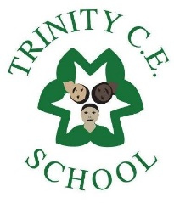

Photo here

Name…………………………………………………………………….
Birthday ………………………………………………………………

The information on these pages helps us to get to know a little about your child as soon as they start, and to settle your child as he/she takes the first important steps into school. Every child is an individual and will have different wants, needs and likes. There are no wrong answers.

Getting to know you

I can draw a picture of myself like this:

Do you take care of everything when you go to the toilet?
(colour me if you can do this)
Do you use a knife and fork when you eat?

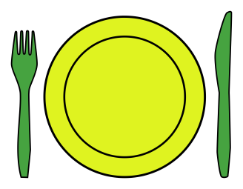 (colour me if you can do this )

Do you dress and undress yourself?
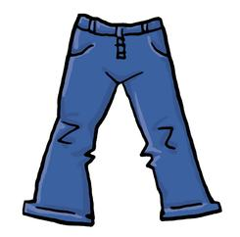
(colour me if you can do this)

I write my name by myself like this:-

I can say the numbers 1 to 10 and I know how old I am:

(colour me if you can do this)

I can write some numbers by myself:

(colour me if you can do this)

I can sit and listen to a story?

(colour me if you can do this)

I can sing an alphabet song?
(colour me if you can do this)

I know some alphabet letter sounds?
(Circle a letter if you can say its sound)

a b c d e f g h i j l m n o
p qu r s t u v w x y z

People my child already knows at school

Things which can upset or worry my child

Ways in which to soothe or calm my child
Places and things my child likes to go to, talk about, do or explore

Favourite stories, songs and rhymes

Favourite toys and games

Words to describe my child! Please write a few words to describe your child.

